**Code smell** 1- String literals should not be duplicated

Code snippet:

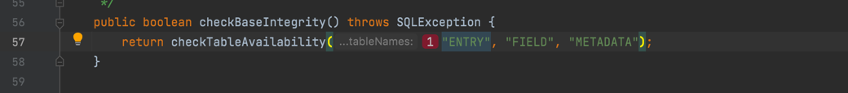

Location of the code: src/main/java/jabref/logic/remote/shared/security/DBMSProcessor.java

In this specific code the string “ENTRY” is repeated 11 times. The same goes for many other strings in the code. This shows lack of attention to repeated code and therefore the code can get long and repetitive.

This code smell can easily be fixed by creating constants for all the words repeated various times. In this case, the word “ENTRY”. The same fix should be applied to all the others.

Refactoring proposal:

**Code smell** 2- Parentheses should be removed from a single lambda input parameter when its type is inferred

Code snippet:

Location of the code: src/main/java/jabref/logic/remote/shared/security/ DBMSProcessor.java

In this specific piece of code there are useless parentheses. It is preferred, if they are not necessary, that parentheses are not used. This code smell can easily be fixed by removing them.

Refactoring proposal:

**Code smell** 3- Parentheses should be removed from a single lambda input parameter when its type is inferred

Code snippet:

Location of the code: src/main/java/jabref/logic/remote/shared/DBMSProcessor.java

Again, in this piece of code happens the same as described before. The parentheses should only be used when necessary.

This code smell can easily be fixed by removing them.

Refactoring proposal:

